**Computer Organization and Assembly Language**

|  |  |
| --- | --- |
| **Lab 09** | |
| **Topic** | 1. MUL, IMUL, DIV and IDIV instructions |

**PART 1**

**Example 1 (Mul and IMUL)**

1. MOV AL, 0x9 ;

MOV BL, 0x7 ;

MUL BL ; The product will be in AX in this case

1. MOV AX, 0x90AB ; DECIMAL 37035

MOV BX, 0x332 ; DECIMAL 818

MUL BX ; NOTE IN THIS CASE THE RESULTANT VALUE IS DOUBLE SO THE HIGHER BITS ARE STORED IN DX REGISTER

1. MOV AX, 0x90AB ; DECIMAL -28501

MOV BX, 0x332 ; DECIMAL 818

IMUL BX ; NOTE IN THIS CASE THE RESULTANT VALUE IS DOUBLE SO THE HIGHER BITS ARE STORED IN DX REGISTER 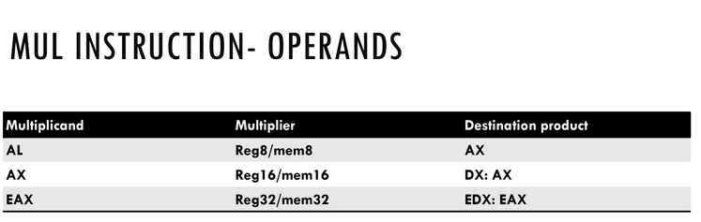

**Example 2 (Div)**

a)

MOV AL, 9 ;

MOV BL, 4 ;

DIV BL ;Divides AX/BL, gives AL=02 (quotient) and AH=01 (remainder);

In this example, it is assumed that value in AH=0

b)

MOV AH,01

MOV AL,9 ; AX=0109

MOV BL, 4 ; BL=04

DIV BL ; 265/4 gives quotient AL=42 hex (66 decimal) and remainder AH=01.

c)

MOV ah, 0x80

mov al,0x23

MOV bx,0x8000;

IDIV bx;Divides [DX:AX]/BX, gives AX=0xFFFF (quotient) and DX=0x23 (remainder);

***Examples for illustrating the differences of MUL and IMUL***

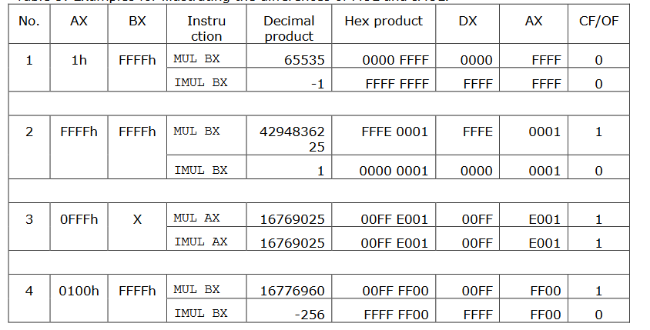

***Examples for illustrating the differences of DIV and IDIV***

